d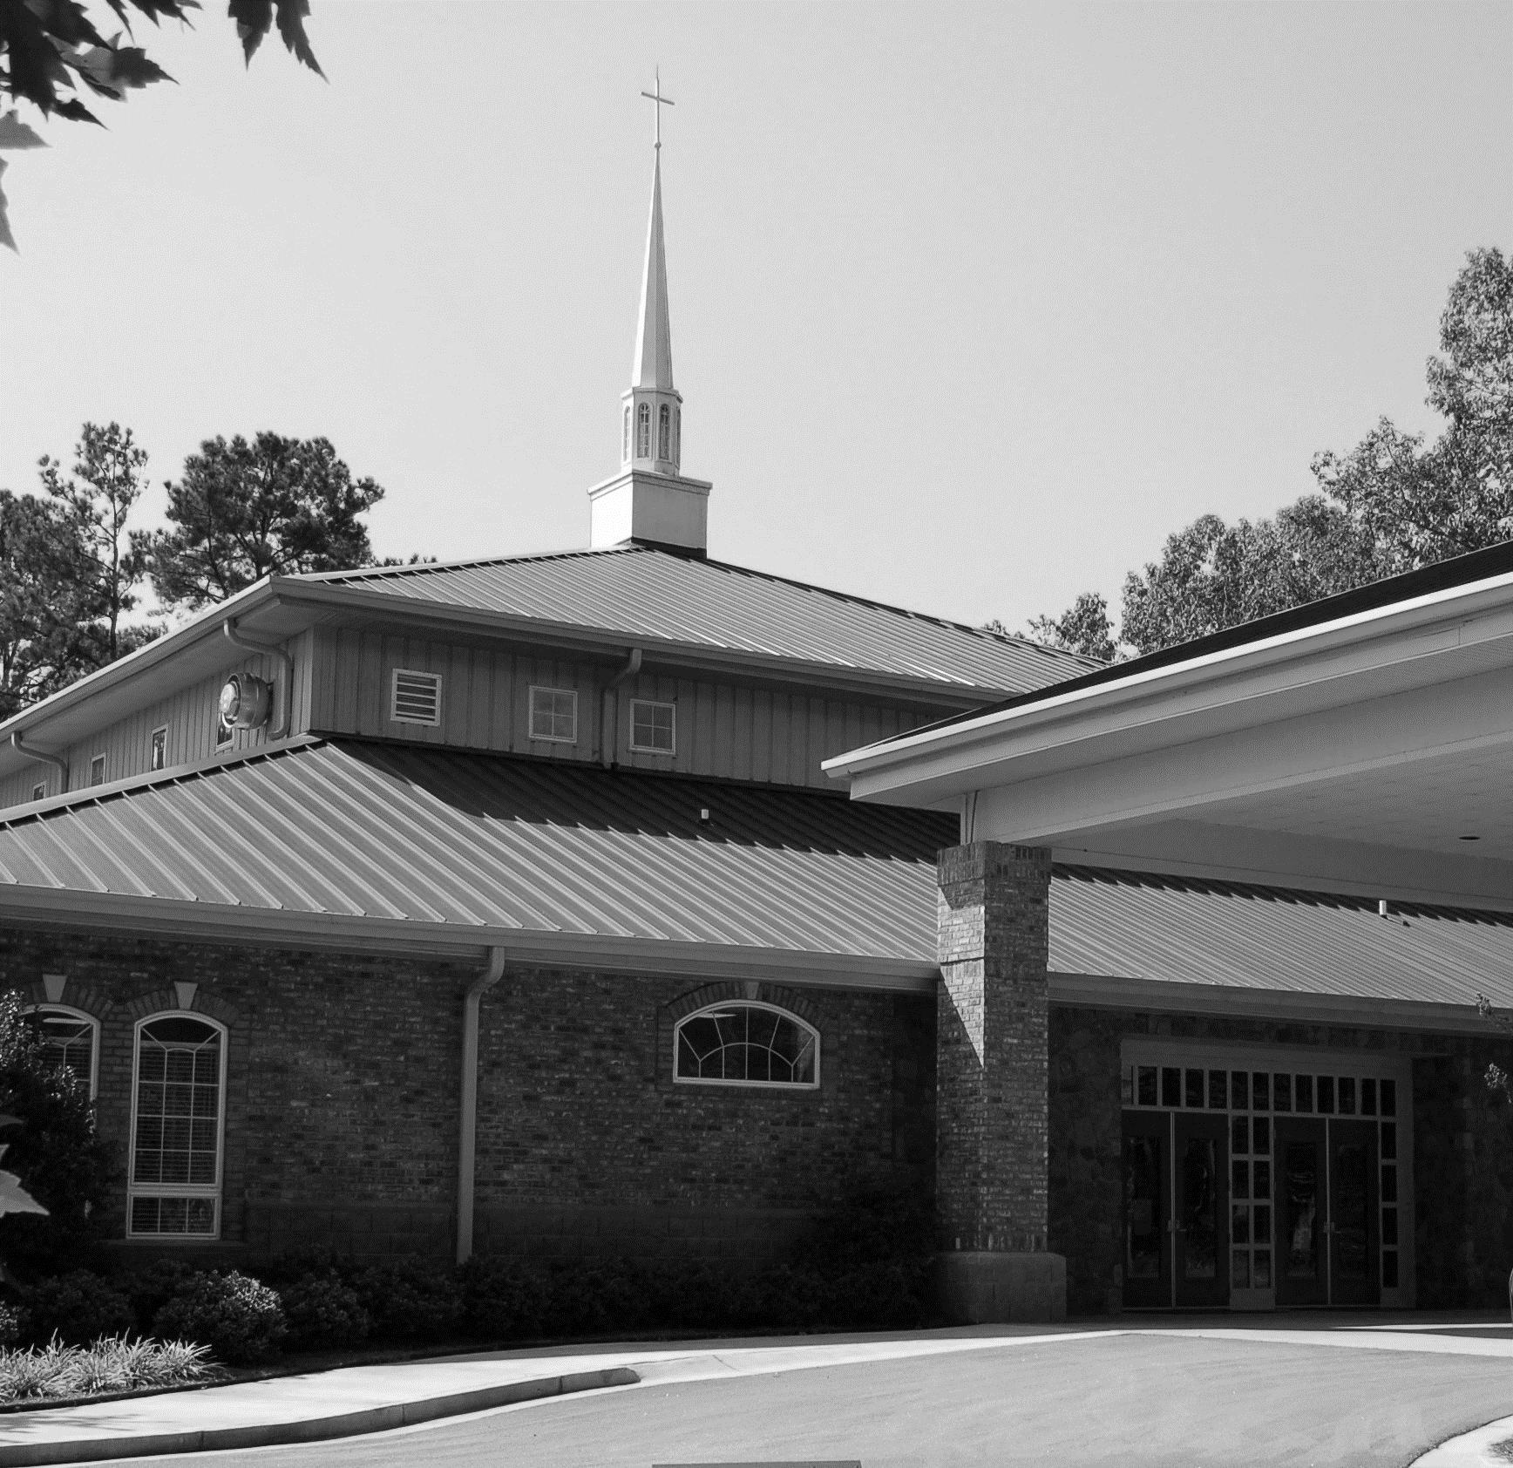

January 9, 2022

LAKE OCONEE LUTHERAN CHURCH
The Baptism of Our Lord
A Stephen Ministry Congregation

God writes His Word on our Lives, building us into a Family engaged
in Spirit-filled Service.

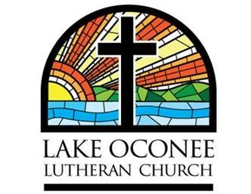
1089 Lake Oconee Parkway
Eatonton, GA 31024
Church Office: 706-485-4600
Sonya Plunkett Church Secretary
www.lakeoconeelutheran.org
Office email: officelolc@gmail.com

Pastor Steven Hayden
Pastor’s Cell: 515-360-5081
Pastor’s email: revshayden@gmail.com

Aids for hearing, children’s activity bulletins, and large print bulletins are available from the ushers

WE OFFER NURSERY & CHILDCARE
If you need childcare, please see one of the ushers
and we will happily accommodate you.

Elder of the Month: Joe Peeples
Scripture reader: Sandy Mathson
Coffee & Fellowship: Robbie & Joe Peeples & Pam Kunz
Pre-Service Music: This is time to turn our hearts & minds toward God in preparation of worship.
Instrumental Prelude Lev Ryabinin
Welcome
Please Stand

(You are invited to wish those around you God’s peace. Please remain standing for the invocation.)

Invocation

Confession and Absolution
P: If we say we have no sin, we deceive ourselves, and the truth is not in us.
C: But if we confess our sins, God, who is faithful and just, will forgive our sins and cleanse us from all unrighteousness.

Silence for reflection on God's Word and for self-examination.

P: Let us then confess our sins to God our Father.
C: Most merciful God, we confess that we are by nature sinful and unclean. We have sinned against You in thought, word, and deed, by what we have done and by what we have left undone. We have not loved You with our whole heart; we have not loved our neighbors as ourselves. We justly deserve Your present and eternal punishment. For the sake of Your Son, Jesus Christ, have mercy on us. Forgive us, renew us, and lead us, so that we may delight in Your will and walk in Your ways to the glory of Your holy name. Amen.

P: Almighty God in His mercy has given His Son to die for you and for His sake forgives you all your sins. As a called and ordained servant of Christ, and by His authority, I therefore forgive you all your sins in the name of the Father and of the Son and of the Holy Spirit.
C: Amen.
Please be seated

Congregational Hymn #400
“Brightest and Best of the Stars of the Morning”
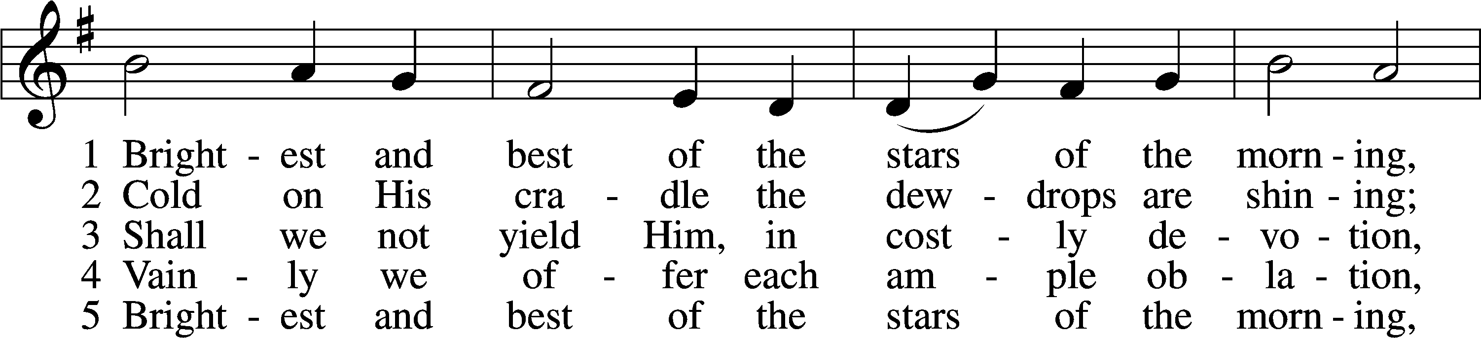
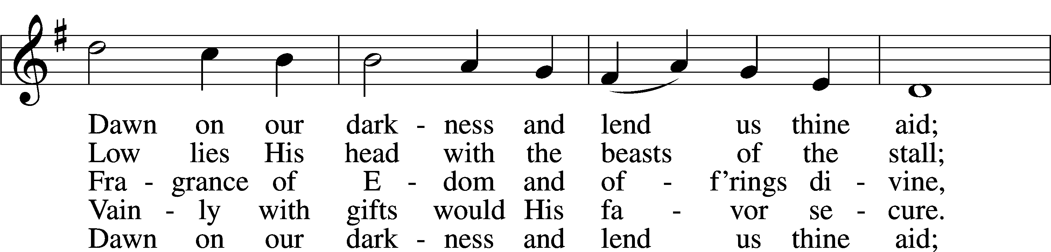
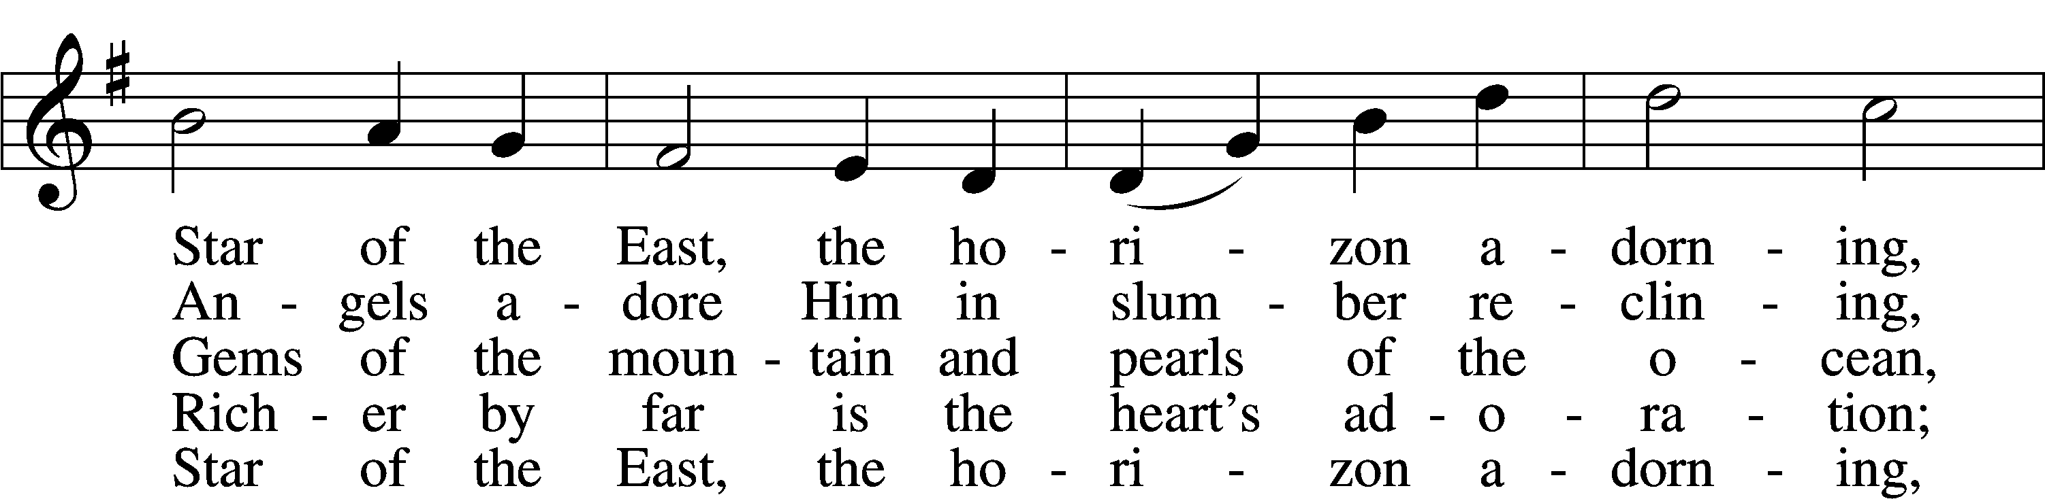
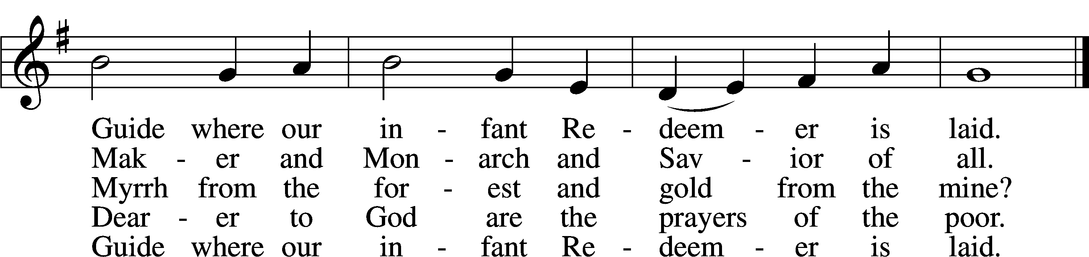
Text and tune: Public domain

Prayer of the Day
P: The Lord be with you.
C: And also with you.
P: Father in heaven, at the Baptism of Jesus in the Jordan River You proclaimed Him Your beloved Son and anointed Him with the Holy Spirit. Make all who are baptized in His name faithful in their calling as Your children and inheritors with Him of everlasting life; through the same Jesus Christ, our Lord, who lives and reigns with You and the Holy Spirit, one God, now and forever.
C: Amen.

The First Lesson: Isaiah 43:1-7
R: ¹But now thus says the Lord, he who created you, O Jacob, he who formed you, O Israel: “Fear not, for I have redeemed you; I have called you by name, you are mine. ²When you pass through the waters, I will be with you; and through the rivers, they shall not overwhelm you; when you walk through fire you shall not be burned, and the flame shall not consume you. ³For I am the Lord your God, the Holy One of Israel, your Savior. I give Egypt as your ransom, Cush and Seba in exchange for you. ⁴Because you are precious in my eyes, and honored, and I love you, I give men in return for you, peoples in exchange for your life. ⁵Fear not, for I am with you; I will bring your offspring from the east, and from the west I will gather you. ⁶I will say to the north, Give up, and to the south, Do not withhold; bring my sons from afar and my daughters from the end of the earth, ⁷everyone who is called by my name, whom I created for my glory, whom I formed and made.”
R: This is the Word of the Lord
C: Thanks be to God

The Epistle Lesson: Romans 6:1-11
R: ¹What shall we say then? Are we to continue in sin that grace may abound? ²By no means! How can we who died to sin still live in it? ³Do you not know that all of us who have been baptized into Christ Jesus were baptized into his death? ⁴We were buried therefore with him by baptism into death, in order that, just as Christ was raised from the dead by the glory of the Father, we too might walk in newness of life. ⁵For if we have been united with him in a death like his, we shall certainly be united with him in a resurrection like his. ⁶We know that our old self was crucified with him in order that the body of sin might be brought to nothing, so that we would no longer be enslaved to sin. ⁷For one who has died has been set free from sin. ⁸Now if we have died with Christ, we believe that we will also live with him. ⁹We know that Christ being raised from the dead will never die again; death no longer has dominion over him. ¹⁰For the death he died he died to sin, once for all, but the life he lives he lives to God. ¹¹So you also must consider yourselves dead to sin and alive to God in Christ Jesus.
R: This is the Word of the Lord
C: Thanks be to God
Please Stand

Common Alleluia and Verse
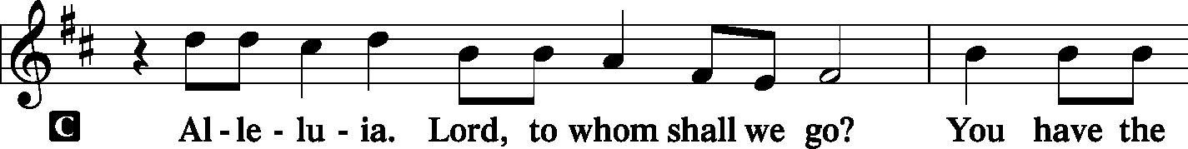
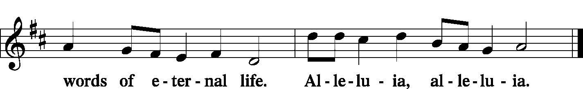

Holy Gospel: Luke 3:15-22
R: The Holy Gospel according to Luke chapter 3
C: Glory to You, O Lord.
R: ¹⁵As the people were in expectation, and all were questioning in their hearts concerning John, whether he might be the Christ, ¹⁶John answered them all, saying, “I baptize you with water, but he who is mightier than I is coming, the strap of whose sandals I am not worthy to untie. He will baptize you with the Holy Spirit and with fire. ¹⁷His winnowing fork is in his hand, to clear his threshing floor and to gather the wheat into his barn, but the chaff he will burn with unquenchable fire.”¹⁸So with many other exhortations he preached good news to the people. ¹⁹But Herod the tetrarch, who had been reproved by him for Herodias, his brother’s wife, and for all the evil things that Herod had done, ²⁰added this to them all, that he locked up John in prison.²¹Now when all the people were baptized, and when Jesus also had been baptized and was praying, the heavens were opened, ²²and the Holy Spirit descended on him in bodily form, like a dove; and a voice came from heaven, “You are my beloved Son; with you I am well pleased.”
R: This is the Gospel of the Lord.
C: Praise to You, O Christ.
Please be seated

Sermon Hymn # 398 v 1-3,5
“Hail to the Lord’s Anointed”
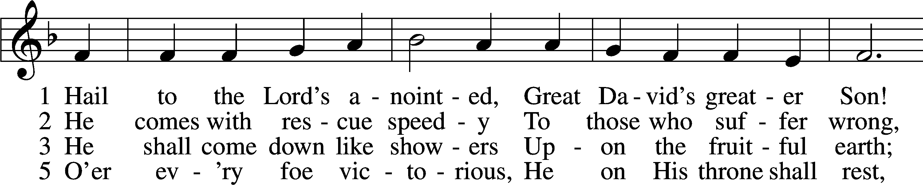
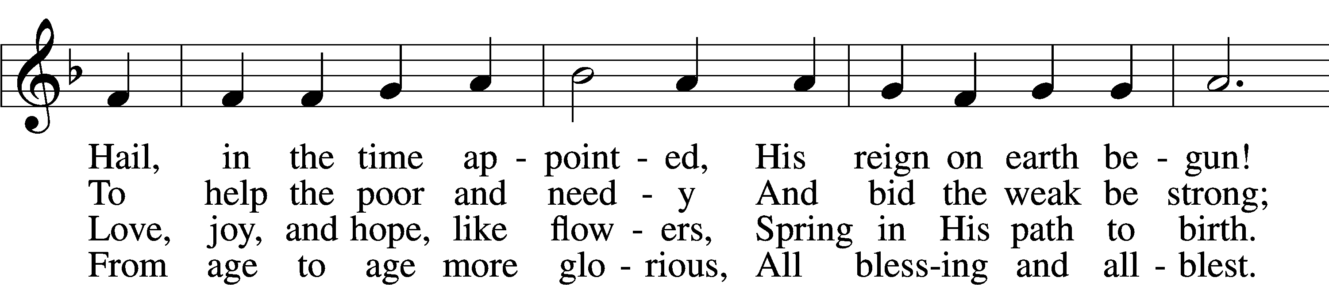
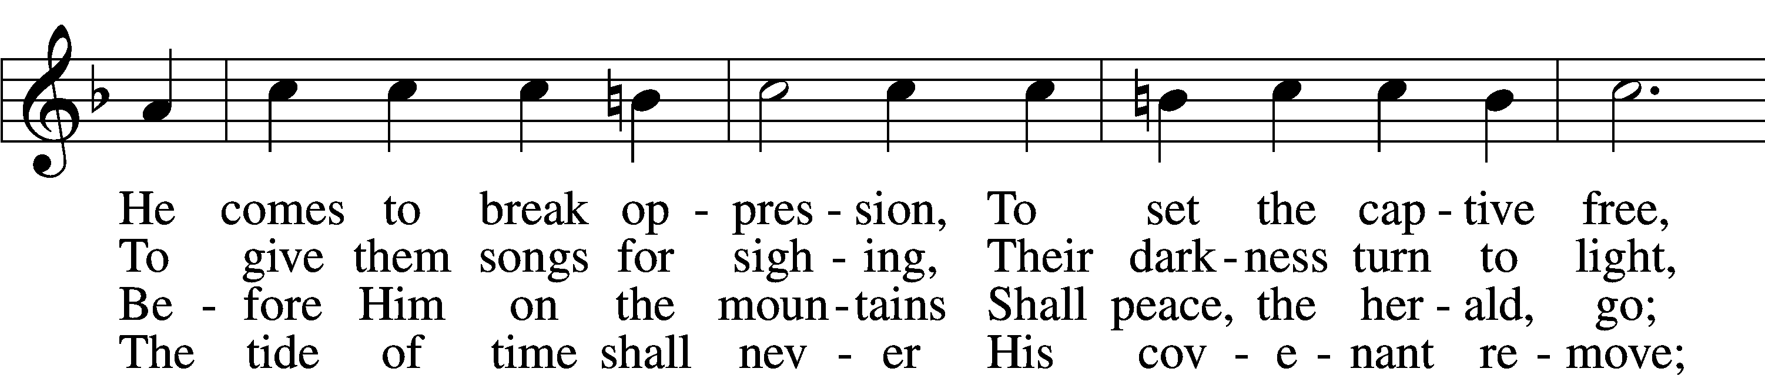
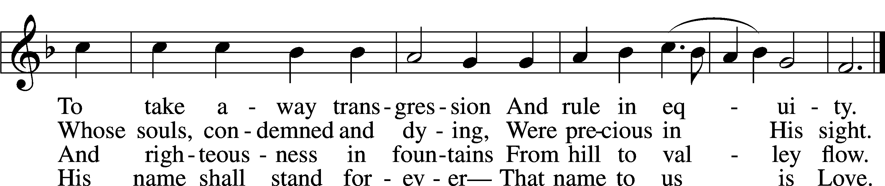
Text and tune: Public domain

The Message Pastor Steve Hayden
Please Stand
Apostles' Creed
C: I believe in God, the Father Almighty, maker of heaven and earth.
And in Jesus Christ, His only Son, our Lord, who was conceived by the Holy Spirit, born of the virgin Mary, suffered under Pontius Pilate, was crucified, died and was buried. He descended into hell.
The third day He rose again from the dead. He ascended into heaven
and sits at the right hand of God the Father Almighty. From thence He will come to judge the living and the dead.
I believe in the Holy Spirit, the holy Christian Church, the communion of saints, the forgiveness of sins, the resurrection of the body, and the life everlasting. Amen.

Offering
To Our Guests: We do not charge for any of our services. All our services, programs, and expenses are freely supported by the gifts and offerings of our members. As our guests, you have not been invited for what you can give, but for what God can give you. The Offering is collected at the door when you enter.
Prayer of the Church
* Prayer of The Church
(After the pastor ends each petition with, “Lord in Your Mercy, the congregation responds with, “Hear our prayer.”)
The Lord's Prayer
C: Our Father who art in heaven, hallowed be Thy name, Thy kingdom come, Thy will be done on earth as it is in heaven; give us this day our daily bread; and forgive us our trespasses as we forgive those
who trespass against us; and lead us not into temptation, but deliver us from evil. For Thine is the kingdom and the power and the glory forever and ever. Amen.

Benediction
P: The Lord bless you and keep you.
The Lord make His face shine on you and be gracious to you.
The Lord look upon you with favor and give you peace.
C: Amen.
Please be seated

Congregational Hymn #388
“Go Tell It on the Mountain”
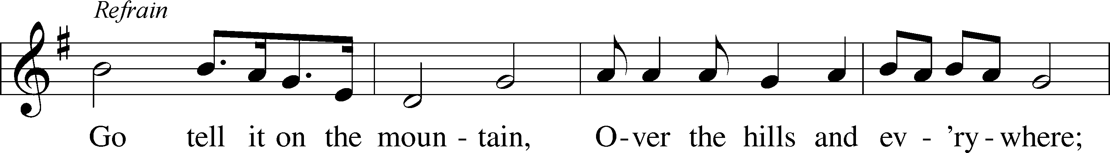
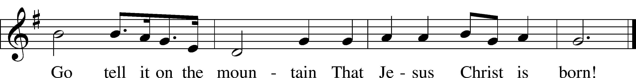
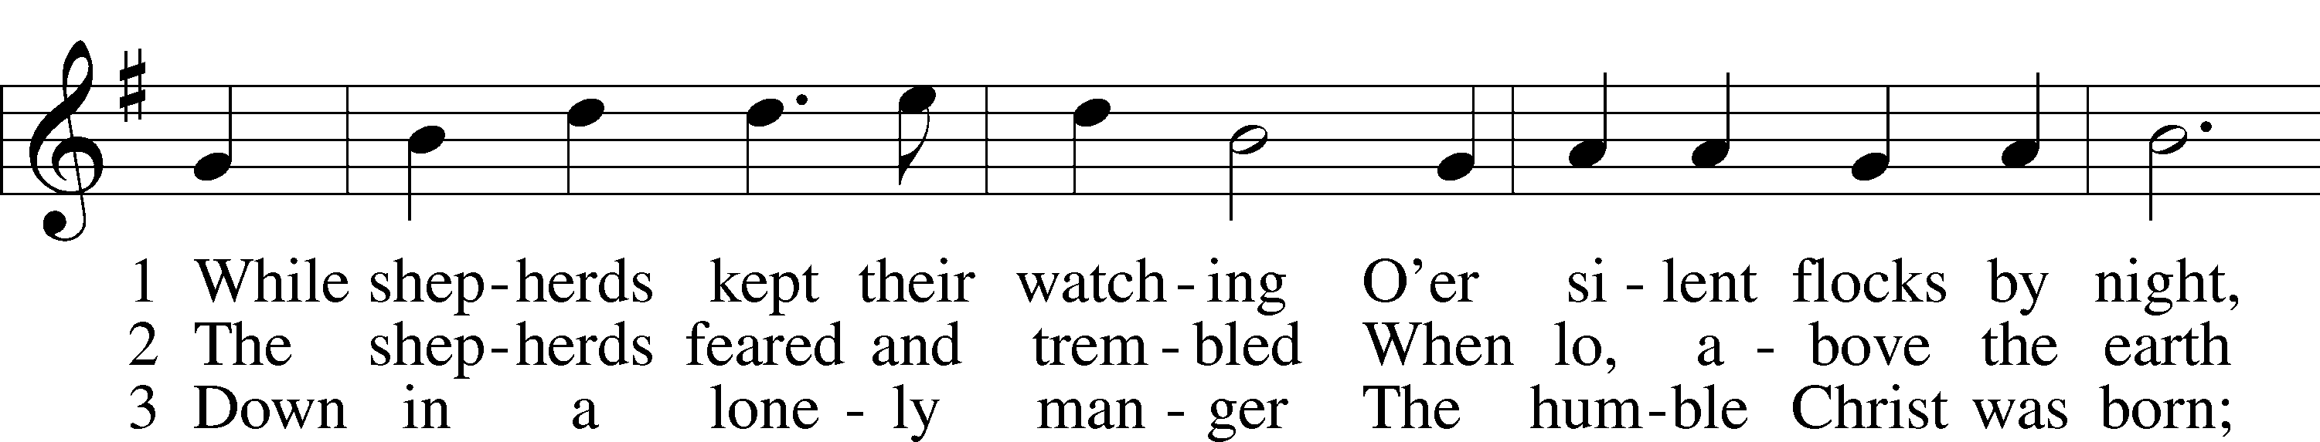
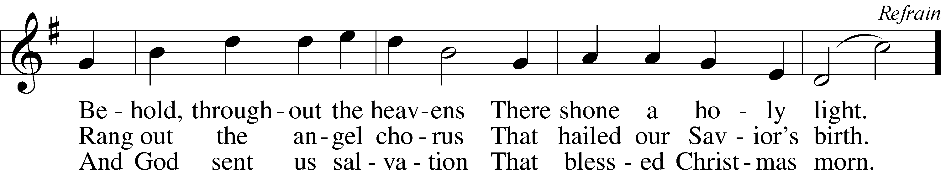
Text and tune: Public domain

Announcements

The Dismissal
P: Go in Peace, Serve the Lord!
C: Thanks be to God!

+ Post-service Music +

GOD’S BLESSINGS to all those celebrating birthdays this week:
- Jan 13 Pam Kunz
and anniversaries
- No Anniversaries this week

Best wishes!

WEEKLY CALENDAR
Sunday Council Meeting After Worship
Tuesday Women’s Bible Class 10 am
Wednesday ZOOM Bible Class No Bible Class
Saturday Episcopal Church worship 5 pm
Sunday Bible Class (In Person) 9 am
Sunday Choir Rehearsal 9 am
Sunday Worship Service 10:30 am

Sunday Morning Bible Class The Book of Esther is a wonderful, true story of God watching over His people and delivering them from certain death. It tells the tale of the young, beautiful Jewish girl, who by God's gracious providence became queen of Persia. With Mordecai, her protective and loving cousin, Esther saves her people by exposing a cruel plot to exterminate the Jews remaining in Persia, who chose not to return to the Promised Land. Although God is never mentioned in the book, He is not hard to find in the many “coincidences,” ironic twists, and reversals recorded therein. Some interpreters have gone so far as to say that God, even in His apparent absence, is the book’s main character. Working behind the scenes, God inspires faith in His gracious promises and enables His children to accomplish extraordinary things on behalf of their neighbor. The Book of Esther is a powerful reminder that God is faithful to His promises and raises up deliverers for His people. Join us every Sunday morning at 9 am, either in person in the Sanctuary or live-streamed on Facebook, for Esther, For Such a Time as This.
Wednesday Zoom Bible Class A psalm is a song or poem distinguished by its devotional character and deep piety. It is the faith of the Old Testament set to music, a poem springing from an encounter with God. It is worship literature. The book of Psalms, as we know it, was not made-it grew, just as our hymnals were not made but grew as person after person through the centuries expressed deep spiritual experiences in poetic form. Christ loved the psalms. Raised as a Jewish boy, He was nourished on the psalms of His people. The psalms were read and sung in His home. He heard them in the synagogue. Later, at His Baptism, His vocation as Messiah was affirmed with Ps. 2:7, "You are My Son." In the night in which He was betrayed, after Jesus instituted the Last Supper, He and the eleven sang a hymn before going to the Mount of Olives (Matt. 26:30). On the cross, when His agony was greatest, Jesus used the words of David (Ps. 22:1) to express the horror of forsakenness. On Easter evening, when Jesus startled the eleven by His sudden appearance, He declared that everything written about Him in the psalms must be fulfilled (Luke 24:44). Most people who know anything about the Bible know a few “literary gems” from the Psalms. But if you are not satisfied with a few oft-quoted verses, then come to a full banquet. You are invited to sit down at the table and enjoy the spiritual food found in the Psalms. Real people, who had real problems and joys, wrote the Psalms. Just as God spoke to the writers of the Psalms, so He speaks to you today. Join us Wednesday mornings at 10:30 am on Zoom for our Bible study on the Book of Psalms – Conversations with God. There will be no Wednesday bible class until Jan 26th.
Don’t forget to Volunteer. There are several Volunteer positions we are looking to and excited to fill. If you are interested in serving, please check out the table in the entryway to see all of the ways to serve.
If you donated a poinsettia and would like to take it home to enjoy it just a little while longer, please feel free to pick it up after worship.

Circle of Love is having an e-waste fundraiser on Wednesday January 12th from 10am to 1 pm in the Lake Oconee Church parking lot (not our parking lot) 1101 Village Park Dr, Greensboro. For more information, please look for the post card flyer on the blue table in the entry way.

LAKE OCONEE LUTHERAN CHURCH
We are Built for a Purpose

Built Through Word and Sacrament –
…believing in and making faithful and frequent use of the Bible, Baptism, and the Lord’s Supper as the means by which God gives and sustains faith and empowers and strengthens us for Christian living.

Built Through Ongoing Learning –
…providing quality, Bible based instruction to foster greater understanding of God’s Word and to better equip members for their discipleship.

Built For Service –
…reaching out to others by word and deed to join in the sharing of God’s blessings and grace, which is free to all believers.

Built For Discipleship –
…utilizing fully our time, talents, and resources to serve and love the Lord, furthering our commission of discipleship.

Built For Fellowship –
…caring for and sharing with our church family; fostering greater love, understanding, and concern for the physical and spiritual well-being of all brothers and sisters in Jesus Christ.

The window behind the altar is our EASTER SUNRISE WINDOW.
The cross hanging in front of the window is an empty cross, reminding us that Jesus rose from the dead and is alive now to be with us here and always. Every Sunday is a celebration of Easter. The symbol on the front of the ALTAR is a combination of two Greek letters: the “chi,” which looks like our English “x,” and the “rho,” which looks like our “p.” In the Greek, these letters are the first two of “Christ.” Combined as they are, they suggest the cross. Superimposed on the cross is a heart, the reminder that God’s love for us is the reason Jesus died on the cross. God’s love for us empowers us to share his love with others.

