d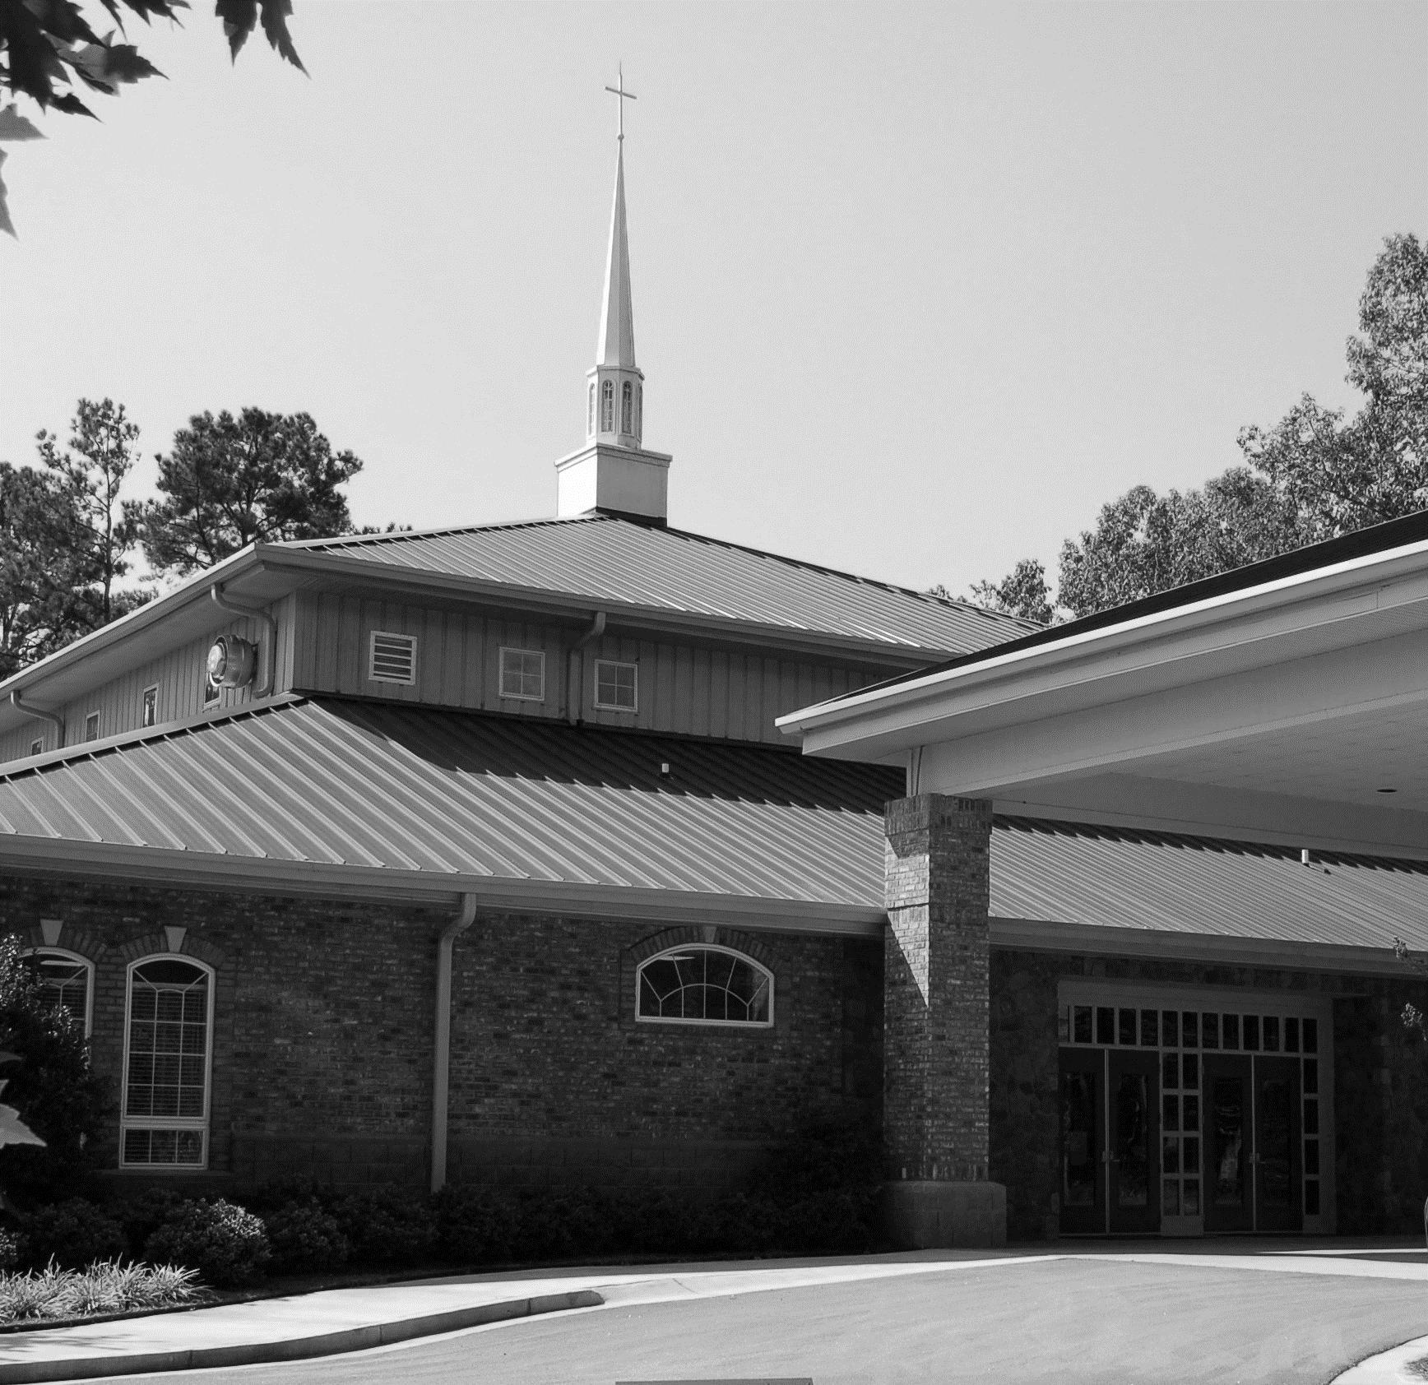

August 22, 2021

LAKE OCONEE LUTHERAN CHURCH
Thirteenth Sunday after Pentecost
A Stephen Ministry Congregation

God writes His Word on our Lives, building us into a Family engaged
in Spirit-filled Service.

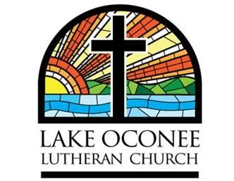
1089 Lake Oconee Parkway
Eatonton, GA 31024
Church Office: 706-485-4600
Sonya Plunkett Church Secretary
www.lakeoconeelutheran.org
Office email: officelolc@gmail.com

Pastor Steven Hayden
Pastor’s Cell: 515-360-5081
Pastor’s email: revshayden@gmail.com

Aids for hearing, children’s activity bulletins, and large print bulletins are available from the ushers

WE OFFER NURSERY & CHILDCARE
If you need childcare, please see one of the ushers
and we will happily accommodate you.

Guest Pastor: Ron Schornhorst
Elder of the Month: Don Menke
Scripture reader: Kathie Kueven
Coffee & Fellowship: Peggy Uehlin
Pre-Service Music: This is time to turn our hearts & minds toward God in preparation of worship.
Instrumental Prelude Lev Ryabinin
Welcome
Please Stand

(You are invited to wish those around you God’s peace. Please remain standing for the invocation.)

Invocation

Confession and Absolution
P: If we say we have no sin, we deceive ourselves, and the truth is not in us.
C: But if we confess our sins, God, who is faithful and just, will forgive our sins and cleanse us from all unrighteousness.

Silence for reflection on God's Word and for self-examination.

P: Let us then confess our sins to God our Father.
C: Most merciful God, we confess that we are by nature sinful and unclean. We have sinned against You in thought, word, and deed, by what we have done and by what we have left undone. We have not loved You with our whole heart; we have not loved our neighbors as ourselves. We justly deserve Your present and eternal punishment. For the sake of Your Son, Jesus Christ, have mercy on us. Forgive us, renew us, and lead us, so that we may delight in Your will and walk in Your ways to the glory of Your holy name. Amen.

P: Almighty God in His mercy has given His Son to die for you and for His sake forgives you all your sins. As an ordained servant of Christ, and by His authority, I therefore forgive you all your sins in the name of the Father and of the Son and of the Holy Spirit.
C: Amen.
Please be seated

Congregational Hymn #563 v1-4
“Jesus, Thy Blood and Righteousness”
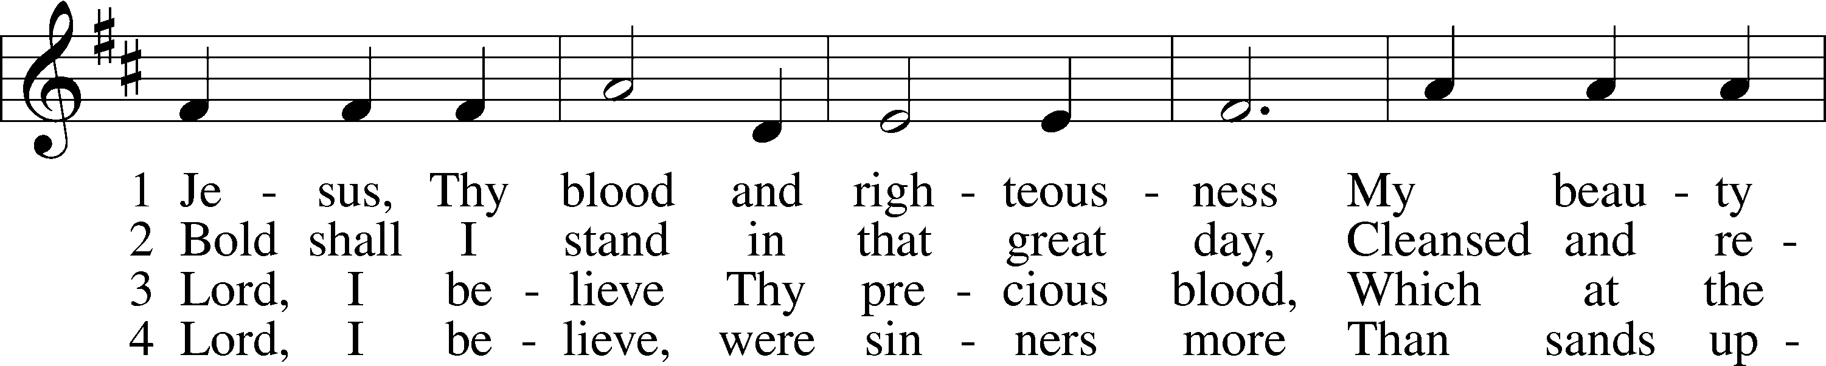
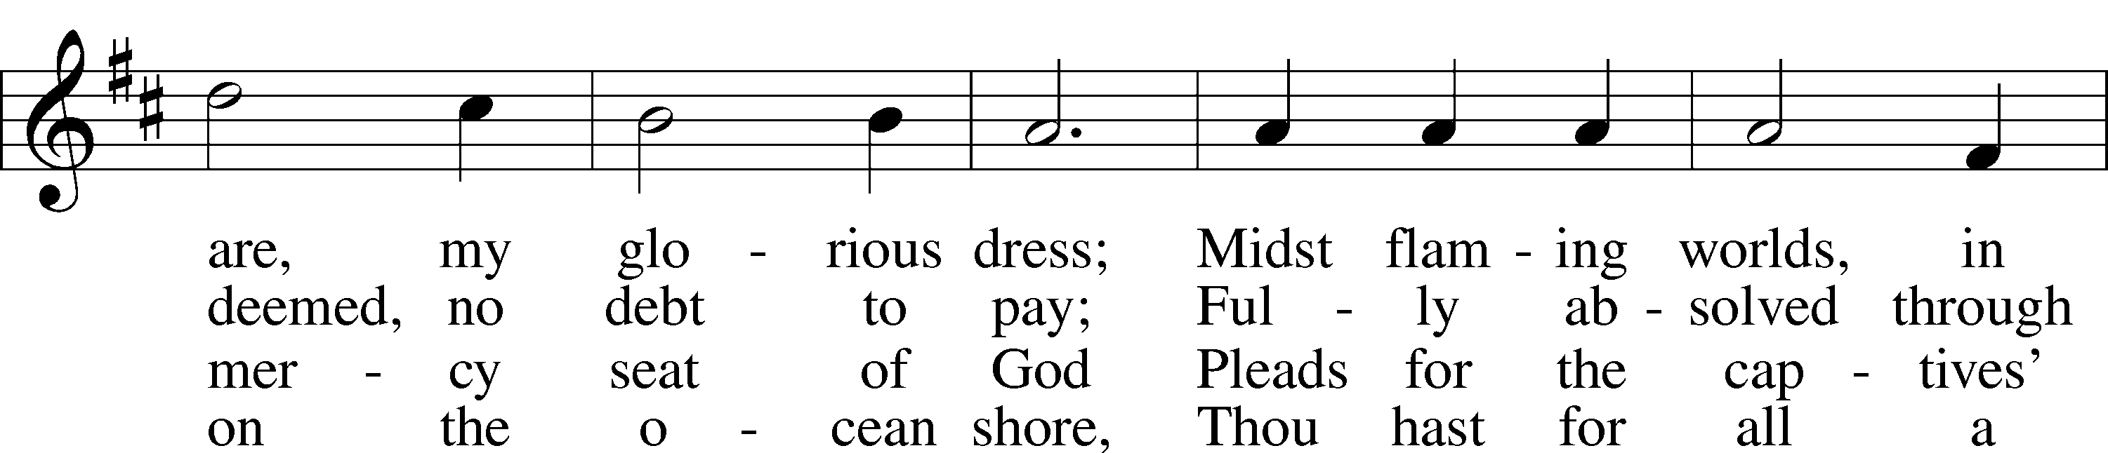
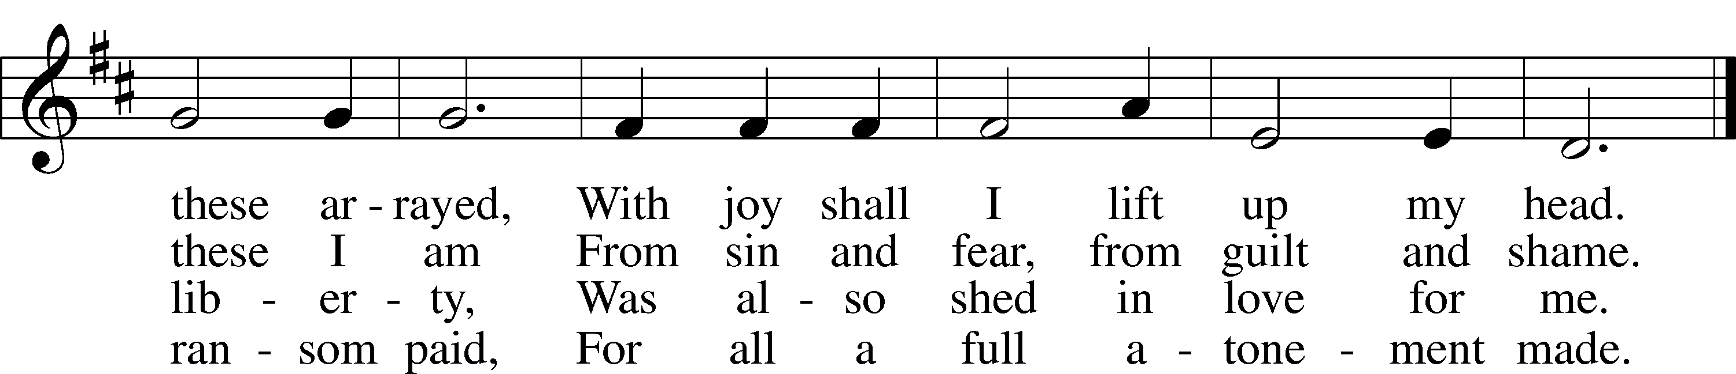
Public domain
Prayer of the Day
P: The Lord be with you.
C: And also with you.
P: Almighty and merciful God, defend Your Church from all false teaching and error that Your faithful people may confess You to be the only true God and rejoice in Your good gifts of life and salvation; through Jesus Christ, Your Son, our Lord, who lives and reigns with You and the Holy Spirit, one God, now and forever.
C: Amen.

The First Lesson: Isaiah 29:11-19
R: ¹¹And the vision of all this has become to you like the words of a book that is sealed. When men give it to one who can read, saying, “Read this,” he says, “I cannot, for it is sealed.” ¹²And when they give the book to one who cannot read, saying, “Read this,” he says, “I cannot read.” ¹³And the Lord said: “Because this people draw near with their mouth and honor me with their lips, while their hearts are far from me, and their fear of me is a commandment taught by men, ¹⁴therefore, behold, I will again do wonderful things with this people, with wonder upon wonder; and the wisdom of their wise men shall perish, and the discernment of their discerning men shall be hidden.” ¹⁵Ah, you who hide deep from the Lord your counsel, whose deeds are in the dark, and who say, “Who sees us? Who knows us?” ¹⁶You turn things upside down! Shall the potter be regarded as the clay, that the thing made should say of its maker, “He did not make me”; or the thing formed say of him who formed it, “He has no understanding”? ¹⁷Is it not yet a very little while until Lebanon shall be turned into a fruitful field, and the fruitful field shall be regarded as a forest? ¹⁸In that day the deaf shall hear the words of a book, and out of their gloom and darkness the eyes of the blind shall see. ¹⁹The meek shall obtain fresh joy in the Lord, and the poor among mankind shall exult in the Holy One of Israel.
R: This is the Word of the Lord
C: Thanks be to God

The Epistle Lesson: Ephesians 5:22-33
R: ²²Wives, submit to your own husbands, as to the Lord. ²³For the husband is the head of the wife even as Christ is the head of the church, his body, and is himself its Savior. ²⁴Now as the church submits to Christ, so also wives should submit in everything to their husbands.
²⁵Husbands, love your wives, as Christ loved the church and gave himself up for her, ²⁶that he might sanctify her, having cleansed her by the washing of water with the word, ²⁷so that he might present the church to himself in splendor, without spot or wrinkle or any such thing, that she might be holy and without blemish. ²⁸In the same way husbands should love their wives as their own bodies. He who loves his wife loves himself. ²⁹For no one ever hated his own flesh, but nourishes and cherishes it, just as Christ does the church, ³⁰because we are members of his body. ³¹“Therefore a man shall leave his father and mother and hold fast to his wife, and the two shall become one flesh.” ³²This mystery is profound, and I am saying that it refers to Christ and the church. ³³However, let each one of you love his wife as himself, and let the wife see that she respects her husband.
R: This is the Word of the Lord
C: Thanks be to God

Please Stand

Common Alleluia and Verse
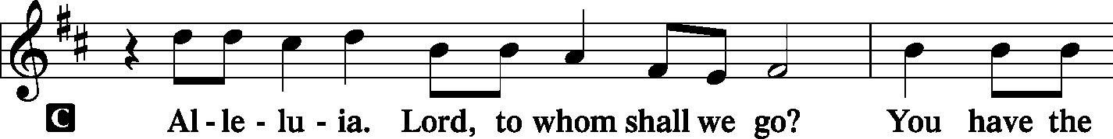
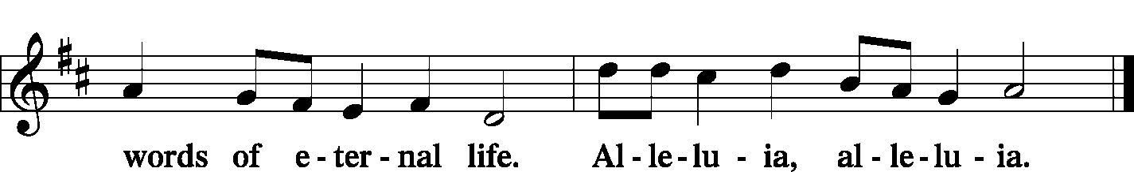

Holy Gospel: Mark 7:1-13
R: The Holy Gospel according to Mark chapter 7
C: Glory to You, O Lord.
R: ¹ When the Pharisees gathered to [Jesus], with some of the scribes who had come from Jerusalem, ²they saw that some of his disciples ate with hands that were defiled, that is, unwashed. ³(For the Pharisees and all the Jews do not eat unless they wash their hands, holding to the tradition of the elders, ⁴and when they come from the marketplace, they do not eat unless they wash. And there are many other traditions that they observe, such as the washing of cups and pots and copper vessels and dining couches.) ⁵And the Pharisees and the scribes asked him, “Why do your disciples not walk according to the tradition of the elders, but eat with defiled hands?” ⁶And he said to them, “Well did Isaiah prophesy of you hypocrites, as it is written, “‘This people honors me with their lips, but their heart is far from me; ⁷in vain do they worship me, teaching as doctrines the commandments of men.’ ⁸You leave the commandment of God and hold to the tradition of men.” ⁹And he said to them, “You have a fine way of rejecting the commandment of God in order to establish your tradition! ¹⁰For Moses said, ‘Honor your father and your mother’; and, ‘Whoever reviles father or mother must surely die.’ ¹¹But you say, ‘If a man tells his father or his mother, Whatever you would have gained from me is Corban’ (that is, given to God)— ¹²then you no longer permit him to do anything for his father or mother, ¹³thus making void the word of God by your tradition that you have handed down. And many such things you do.”
R: This is the Gospel of the Lord.
C: Praise to You, O Christ.

Please be seated

Sermon Hymn # 589
“Speak, O Lord, Your Servant Listens”
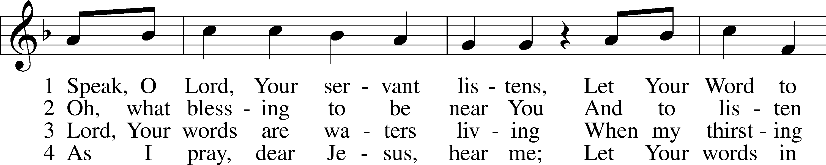
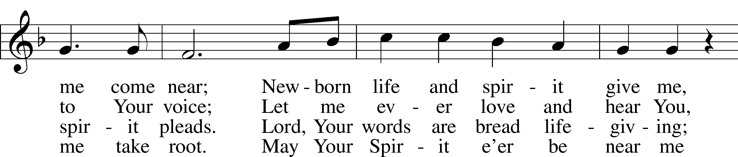
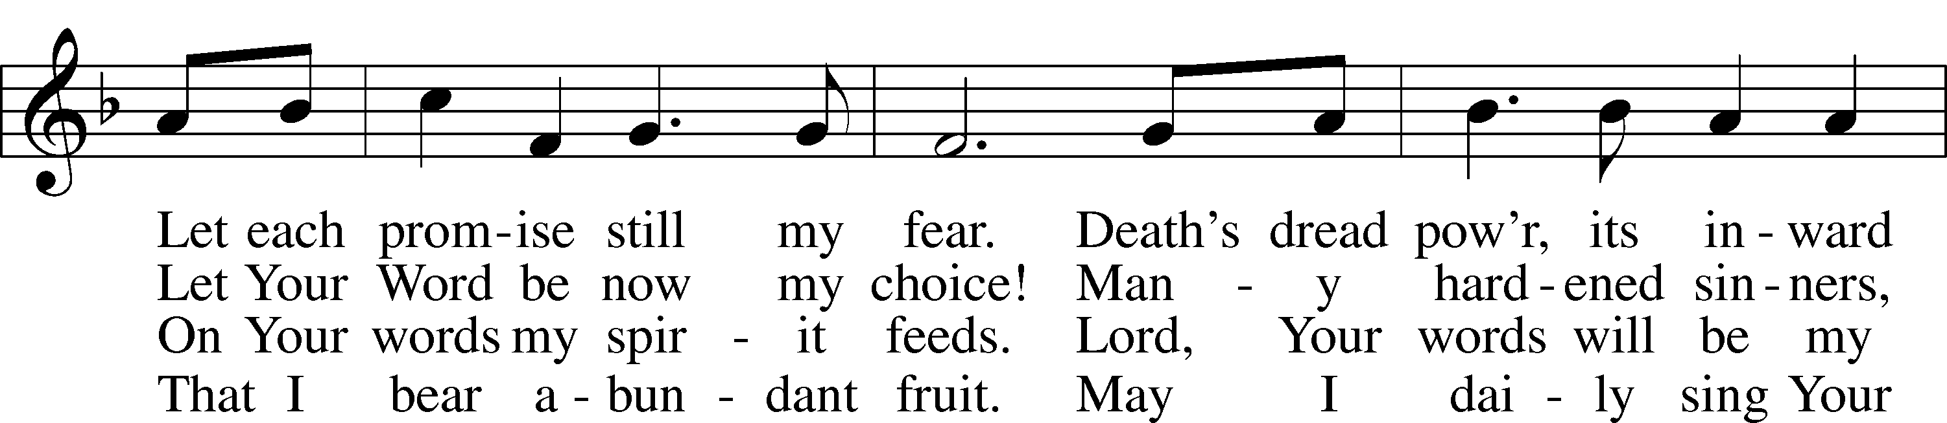
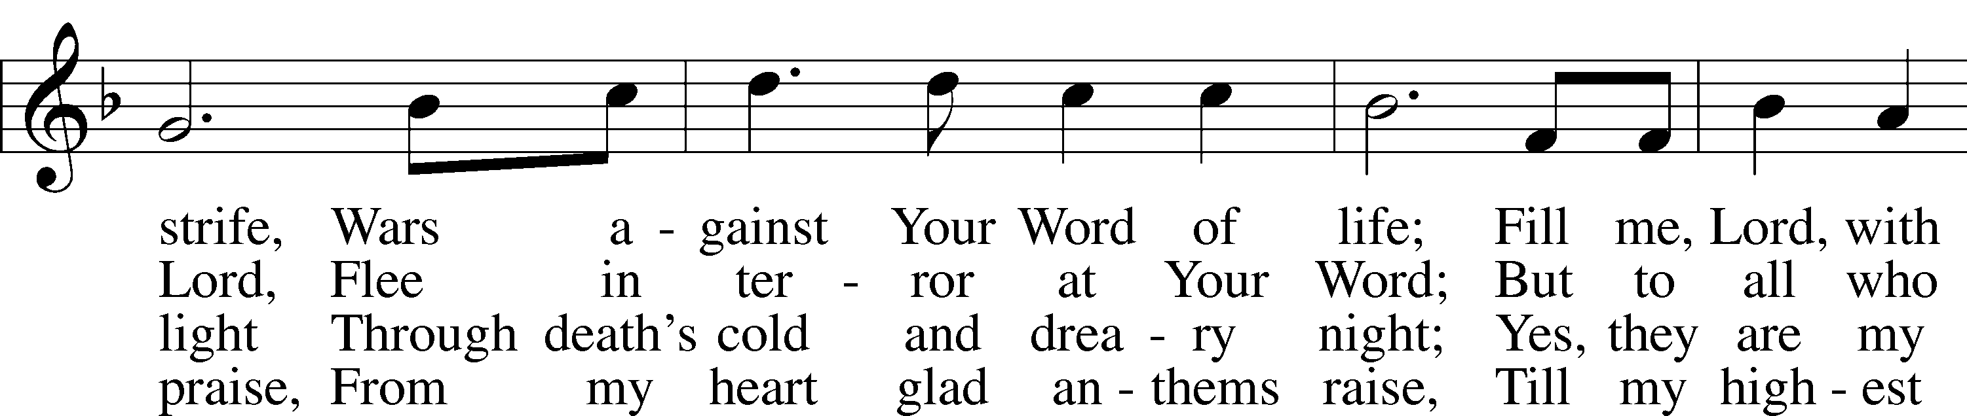
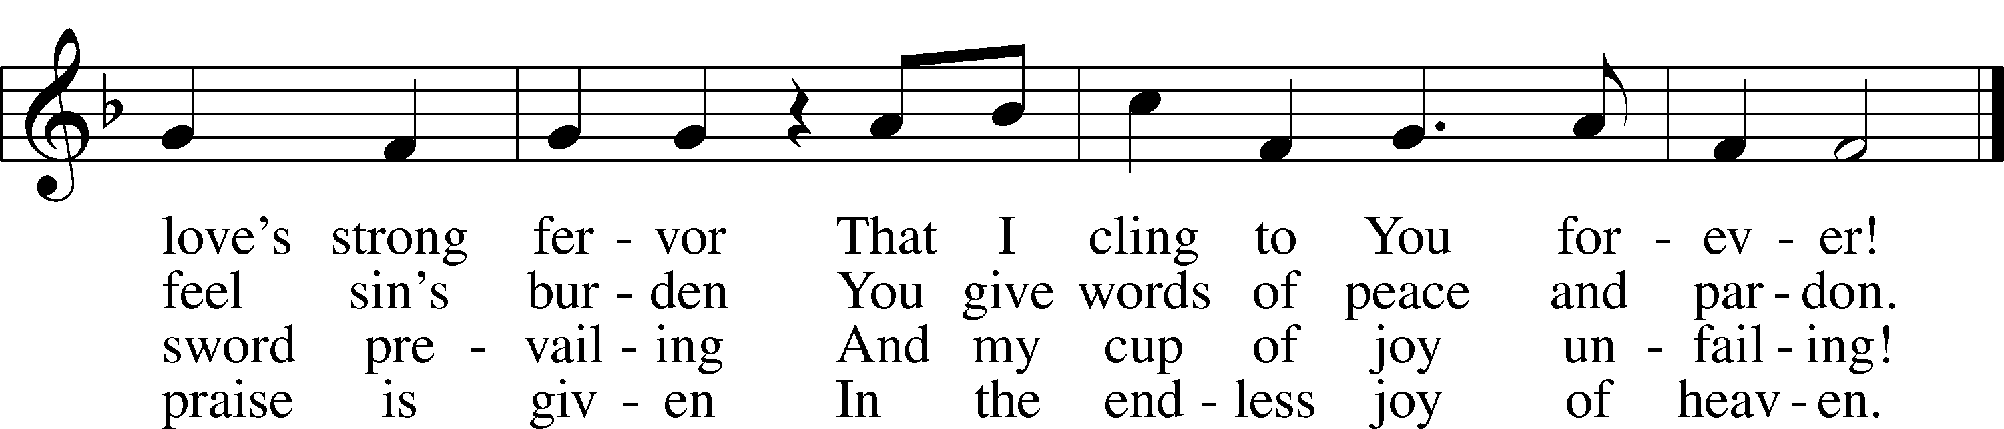
Public domain

The Message Pastor Ron Schornhorst
Please Stand

Apostles' Creed
C: I believe in God, the Father Almighty, maker of heaven and earth.
And in Jesus Christ, His only Son, our Lord, who was conceived by the Holy Spirit, born of the virgin Mary, suffered under Pontius Pilate, was crucified, died and was buried. He descended into hell.
The third day He rose again from the dead. He ascended into heaven
and sits at the right hand of God the Father Almighty. From thence He will come to judge the living and the dead.
I believe in the Holy Spirit, the holy Christian Church, the communion of saints, the forgiveness of sins, the resurrection of the body, and the life everlasting. Amen.
Offering
To Our Guests: We do not charge for any of our services. All our services, programs, and expenses are freely supported by the gifts and offerings of our members. As our guests, you have not been invited for what you can give, but for what God can give you. The Offering is collected at the door when you enter.

Prayer of the Church
* Prayer of The Church
(After the pastor ends each petition with, “Lord in Your Mercy, the congregation responds with, “Hear our prayer.”)
The Lord's Prayer
C: Our Father who art in heaven, hallowed be Thy name, Thy kingdom come, Thy will be done on earth as it is in heaven; give us this day our daily bread; and forgive us our trespasses as we forgive those
who trespass against us; and lead us not into temptation, but deliver us from evil. For Thine is the kingdom and the power and the glory forever and ever. Amen.

Benediction
P: The Lord bless you and keep you.
The Lord make His face shine on you and be gracious to you.
The Lord look upon you with favor and give you peace.
C: Amen.
Please be seated

Congregational Hymn #555 v 1,4,6,9
“Salvation unto Us Has Come”
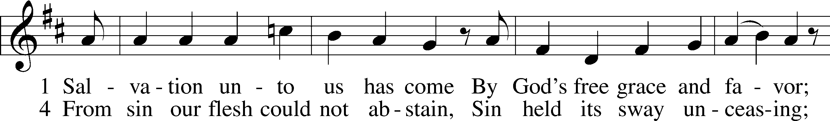
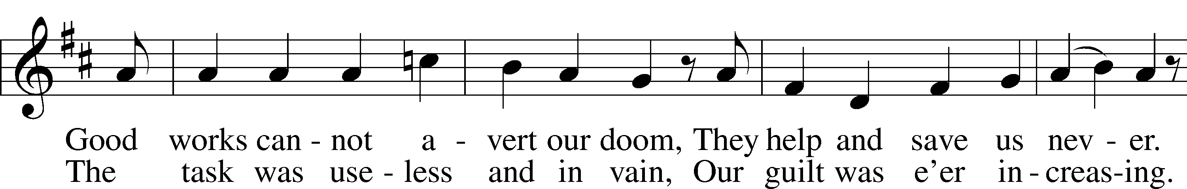
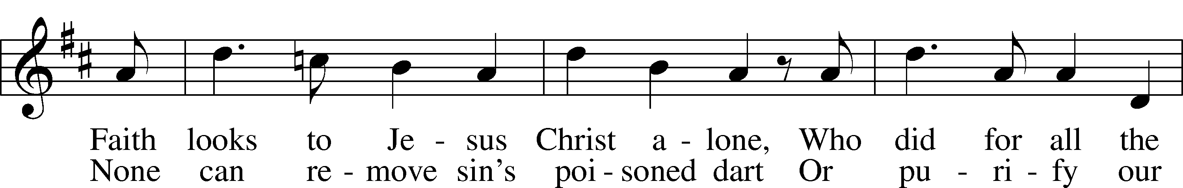
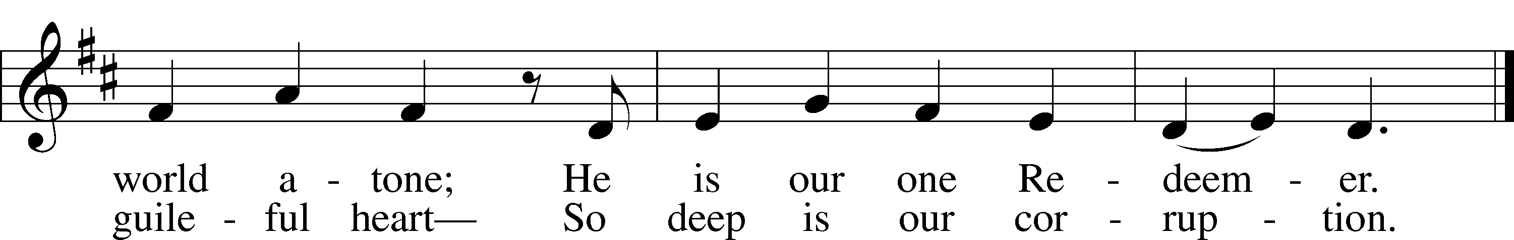

6 Since Christ has full atonement made
And brought to us salvation,
Each Christian therefore may be glad
And build on this foundation.
Your grace alone, dear Lord, I plead,
Your death is now my life indeed,
For You have paid my ransom.

9 Faith clings to Jesus’ cross alone
And rests in Him unceasing;
And by its fruits true faith is known,
With love and hope increasing.
For faith alone can justify;
Works serve our neighbor and supply
The proof that faith is living.
Public domain
Announcements
Birthdays & Anniversaries
The Dismissal
P: Go in Peace, Serve the Lord!
C: Thanks be to God!
+ Post-service Music +
GOD’S BLESSINGS to all those celebrating birthdays this week:
- August 27 Jim Kueven
and anniversaries
- No anniversaries this week
Best wishes!

WEEKLY CALENDAR
Tuesday Women’s Bible Class 10am
Wednesday ZOOM Bible Class No class this week
Thursday Blood Drive 1pm
Saturday Episcopal Church worship 5 pm
Sunday Bible Class (In Person) 9 am
Sunday Worship Service 10:30 am

Sunday Morning Bible Class Throughout all of Holy Scripture, there is an overarching theme of death versus life. At times, this is played out in the physical sense. People die and people are given new life, or resurrected. Moreover, the theme of death versus life finds its culmination in the death and resurrection of Jesus Christ. He is forsaken by His Father and killed in the body. He is loved by His Father and raised in the body. However, each instance of death versus life also has a deeper meaning. There is not only a battle between physical death and life, but also between spiritual death and life. Every biblical example of death with an ensuing resurrection serves to remind us of what happens to us and every Christian. We are all spiritually dead, yet in Jesus Christ and through His death and resurrection, we, once dead human beings, are resurrected and made children of God. Join us on Sunday mornings at 9 am for Resurrections.
Wednesday Zoom Bible Class When you hear the word angel, what image comes to mind? Clarence from the movie It’s A Wonderful Life? Tess from Touched by an Angel? Popular culture formerly portrayed angels as harp-carrying spirits lounging on comfortable white tufts of cloud or as pastel-colored feminine virtues or chubby, winged infants. On the other hand, what comes to mind when you hear the words demon or devil? Hellboy from the comic book series or the movie? Various heinous creatures from The Lord of the Rings? Or when you think about angels and demons, do you think of those comical creatures sitting on someone’s shoulders—an angel in a white gown and wings on one shoulder and a demon with a pitchfork and pointy tail sitting on the other? For many people, popular films, books, comic books, and other media are their only sources of information about angels and demons—if they believe in these creatures at all. These are inaccurate portrayals of angels and demons. In contrast, we will share the truth about angels and demons using God’s errorless Word. What the Bible says about angels, demons, and other related topics is vitally important to Lutherans because what God says about these matters can be trusted. Join us on Wednesday morning Zoom Bible class at 10:30 for Angels and Demons starting on Wednesday, September 8th No class August 28th or Sept 1st
Women’s Bible Study. The devotional Life by Lisa Harper shows us the Gospel is truly Good News for your actual, every day, sometimes painful or difficult life. It’s a reminder that God’s faithfulness follows us through the harried, hard and humorous things in life. Join us anytime for this conversational series. Women's Bible Study meets Tuesdays at 10 am in the choir room.

Operation Christmas child collections are being split up into specific items for each month. We have created an Amazon wish list to make shopping easier for you. The specific items for the collection of the month will be on the wish list with the number of how many are needed in total. The direct link is emailed out in the church’s Thursday email. If you do not receive those emails, you can contact the church office and we will email you a direct link. You can also purchase the items locally if you desire and bring them to church.

We are in need of Volunteers. We are looking for volunteers to sign up for Coffee fellowship, Camera Operators, and Communion Ushers. Look for sign-up sheets in the entry on the blue table.

Back-to-School Support “Remember the excitement and anticipation of the first day of school? Part of the excitement was new stuff – pencils, crayons, notebooks and more. Our Mission-of-the-Month for the summer has focused on Operation Christmas Child, which supports the needs of children internationally. Our LOLC Service/Outreach ministry would like to additionally bring some focus on children in our own community the 900 elementary students in Putnam and Greene counties.
Specifically, we’re looking for:
- 24 count boxes of crayons, - Packs of #2 pencils, - Plastic folders with prongs. Look for the bin labeled Back-to-School Supplies that will be in the church entry for the month of August. We’ll distribute contributions to the schools the first week of September. Thank you for your support of children both far and near.”

Our August Blood drive is the 26th, If you are interested in donating your time, please reach out to Pam Kunz at kunzpd3@outlook.com. To donate blood sign up at redcrossblood.org and use code lolc.

LAKE OCONEE LUTHERAN CHURCH
We are Built for a Purpose

Built Through Word and Sacrament –
…believing in and making faithful and frequent use of the Bible, Baptism, and the Lord’s Supper as the means by which God gives and sustains faith and empowers and strengthens us for Christian living.

Built Through Ongoing Learning –
…providing quality, Bible based instruction to foster greater understanding of God’s Word and to better equip members for their discipleship.

Built For Service –
…reaching out to others by word and deed to join in the sharing of God’s blessings and grace, which is free to all believers.

Built For Discipleship –
…utilizing fully our time, talents, and resources to serve and love the Lord, furthering our commission of discipleship.

Built For Fellowship –
…caring for and sharing with our church family; fostering greater love, understanding, and concern for the physical and spiritual well-being of all brothers and sisters in Jesus Christ.

The window behind the altar is our EASTER SUNRISE WINDOW.
The cross hanging in front of the window is an empty cross, reminding us that Jesus rose from the dead and is alive now to be with us here and always. Every Sunday is a celebration of Easter. The symbol on the front of the ALTAR is a combination of two Greek letters: the “chi,” which looks like our English “x,” and the “rho,” which looks like our “p.” In the Greek, these letters are the first two of “Christ.” Combined as they are, they suggest the cross. Superimposed on the cross is a heart, the reminder that God’s love for us is the reason Jesus died on the cross. God’s love for us empowers us to share his love with others.

