Wednesday December 8, 2021
Advent Service

As We Gather We live with all kinds of expectations, from what is going to happen next week to what are we expecting for Christmas. At times, we even may wonder what to expect from God. Tonight God reminds us that He exceeds all human expectations. As sinners we should expect judgment and condemnation, but instead He gives us grace and acceptance. Instead of rejection, we receive Jesus, the incarnate Son of God.

The Invocation
P In the name of the Father and of the + Son and of the Holy Spirit.
A voice cries out, “In the wilderness clear a way for the Lord;
C make a way in the desert, a road for our God.
P Every valley must be lifted up, and every mountain and hill leveled.
C The rough places will become a level plain, the rugged land a wide valley.
P The glory of the Lord will be revealed, and all people will see it at the same time.
C For the Lord has decreed it.”
P “Go up on a high mountain, O herald Zion!
C Shout out loudly, O herald Jerusalem! Shout, don’t be afraid!
P Say to the towns of Judah, ‘Here is your God!’”
C “Behold, a virgin shall conceive and bear a son.
P And they shall call his name Immanuel (which means God with us).”
C “The Word became flesh and dwelt among us, and we have seen his glory, glory as of the only Son from the Father, full of grace and truth.”

Confession and Absolution
P: Let us confess our sins to God and ask his forgiveness.
C Faithful Father, who sent Jesus as the fulfillment of the promised Savior, we confess that our distracted doing has shrouded our Advent and turned us to follow our own way. Forgive us for shaping the celebration to fit our desires. Seize us by your Spirit. Focus our eyes and hearts on the coming Christ. Inspire us with Christ’s advent so that we shout from the housetops the Good News that in the coming Savior God is indeed with us. Make us into your joy-filled messengers, sharing your powerful Word of salvation for all.
P Jesus has promised that the sins we forgive on earth will also be forgiven in heaven. Trusting that precious promise, as a called and ordained minister of the Gospel, I confidently declare to you that, in Jesus Christ, all of your sins are forgiven and you are privileged to share that same forgiveness with all the others in your life. We are filled with Jesus’ light of life so that we can shine among the people of this world like stars in the sky.

The Hymn O Come, O Come, Emmanual Hymn 357 v 1-4
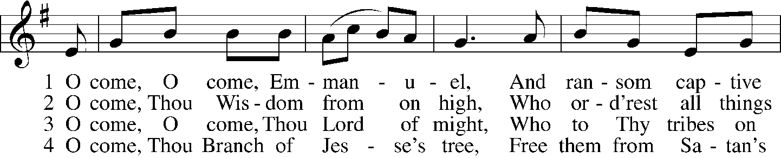
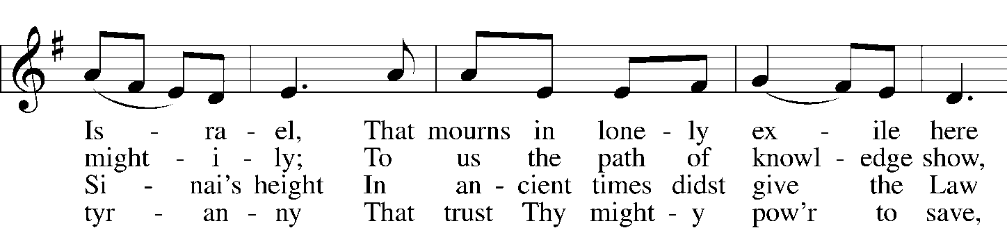
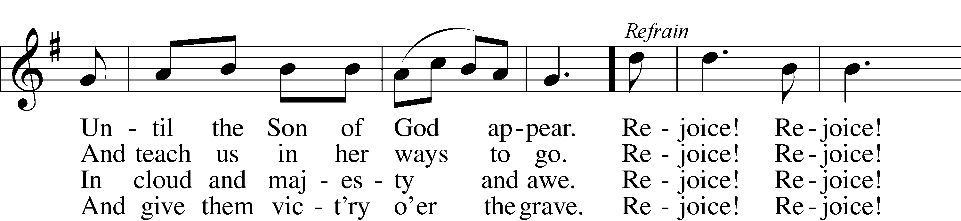
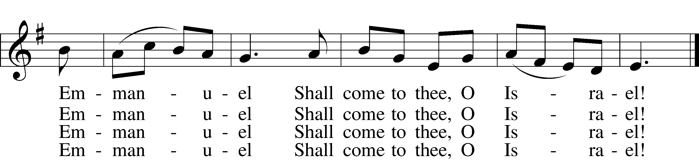

ref Rejoice! Rejoice! Emmanuel
Shall come to thee, O Israel!
Public domain

The Prayer of the Day
P Promised Savior, living Lord, we celebrate the new life you bring through your life, death and resurrection. We give thanks for your coming, for your promised salvation. As root of Jesse, the coming promised new life grown from the patriarch and prophets, we open our hearts to receive you this Advent time and join the saints through the ages in witnessing to the gift of faith and life that you bring to us and to all. We affirm your rule along with the Father and the Spirit. Amen.

Old Testament Reading Zephaniah 3:14-17
14 Sing aloud, O daughter of Zion; shout, O Israel! Rejoice and exult with all your heart, O daughter of Jerusalem! 15 The LORD has taken away the judgments against you; he has cleared away your enemies. The King of Israel, the LORD, is in your midst; you shall never again fear evil. 16 On that day it shall be said to Jerusalem: “Fear not, O Zion; let not your hands grow weak. 17 The LORD your God is in your midst, a mighty one who will save; he will rejoice over you with gladness; he will quiet you by his love; he will exult over you with loud singing.

Gospel Reading Luke 1:18-25, 57
¹⁸ And Zechariah said to the angel, “How shall I know this? For I am an old man, and my wife is advanced in years.” ¹⁹ And the angel answered him, “I am Gabriel. I stand in the presence of God, and I was sent to speak to you and to bring you this good news. ²⁰ And behold, you will be silent and unable to speak until the day that these things take place, because you did not believe my words, which will be fulfilled in their time.” ²¹ And the people were waiting for Zechariah, and they were wondering at his delay in the temple. ²² And when he came out, he was unable to speak to them, and they realized that he had seen a vision in the temple. And he kept making signs to them and remained mute. ²³ And when his time of service was ended, he went to his home. ²⁴ After these days his wife Elizabeth conceived, and for five months she kept herself hidden, saying, ²⁵ “Thus the Lord has done for me in the days when he looked on me, to take away my reproach among people.”… ⁵⁷ Now the time came for Elizabeth to give birth, and she bore a son.

The Hymn “Hark! A Thrilling Voice is Sounding” Hymn 345
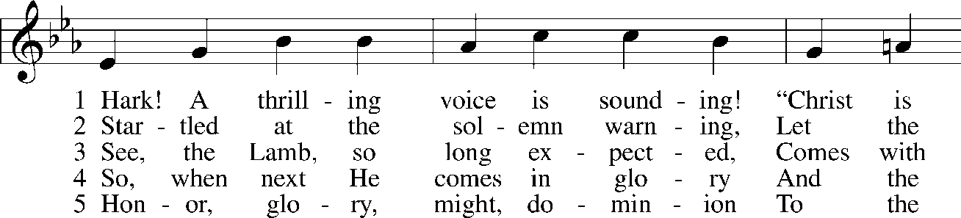
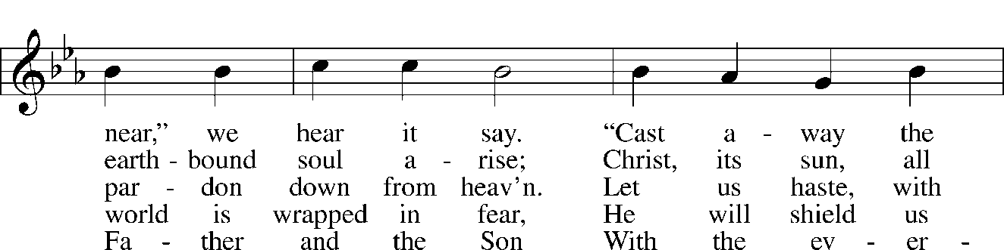
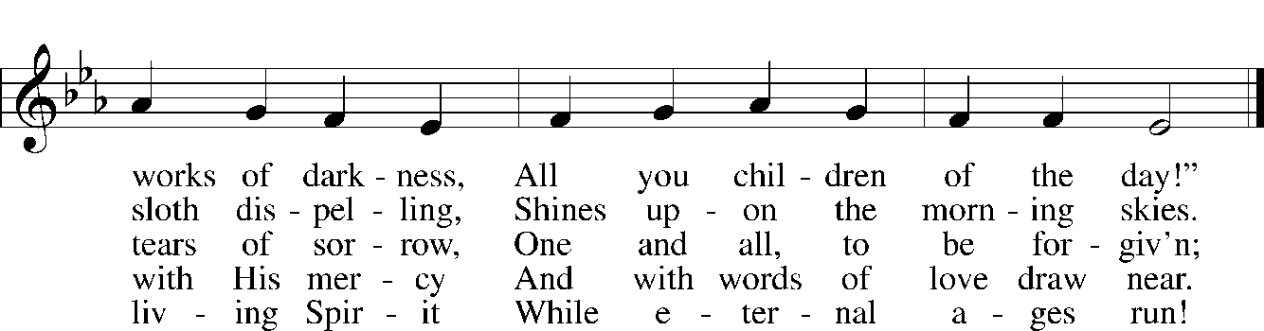
Public domain

The Message
The Offering

The Prayers
Pastor: Advent Lord, we long for your return.
People: Come, Lord Jesus!
Pastor: Lord and Savior, forgive us when we are too busy to worship you. Forgive us when we grow impatient and unkind toward others and put our preparations ahead of the people in our lives. Help us to look forward to our celebrations with joy and peace. Advent Lord, we long for your return.
People: Come, Lord Jesus!
Pastor: Lord and Savior, lead us to help those in need during this holiday season, to share with others the blessings you have given us. Comfort those who suffer in illness, grief or loneliness, especially those we name in our hearts … Advent Lord, we long for your return.
People: Come, Lord Jesus!
Pastor: Lord and Savior, because of your death and resurrection, we can now serve you without fear, in holiness and righteousness before you all the days of our lives. Fill us with joy as we prepare to celebrate your birth, and let our joy overflow into the lives of others, so that they too will worship you as their Savior. Advent Lord, we long for your return.
People: Come, Lord Jesus!
Pastor: Amen.

The Lord’s Prayer
Our Father who art in heaven, hallowed be Thy name, Thy kingdom come, Thy will be done on earth as it is in heaven; give us this day our daily bread; and forgive us our trespasses as we forgive those
who trespass against us; and lead us not into temptation, but deliver us from evil. For Thine is the kingdom and the power and the glory forever and ever. Amen.

The Blessing
Pastor; The Lord Almighty, Father, Son and Holy Spirit, grant us a quiet night and peace at the last.
People: Amen.

The Closing Hymn “Come, Thou Long-Expected Jesus” Hymn 338
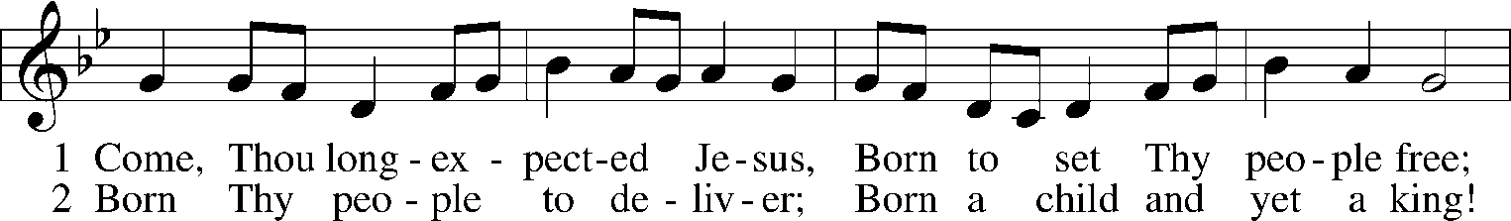
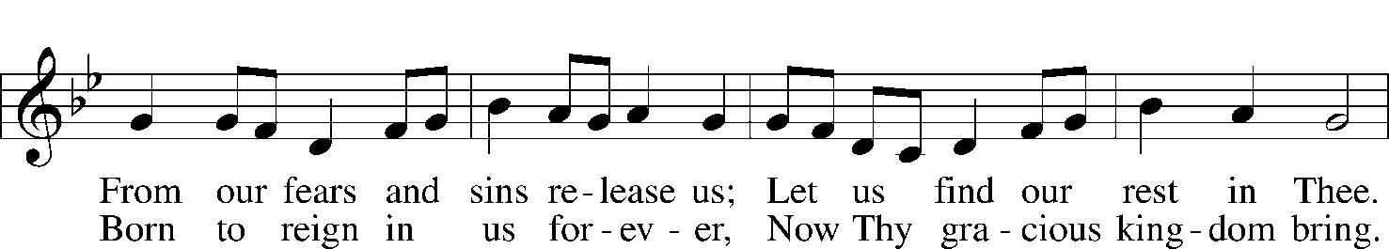
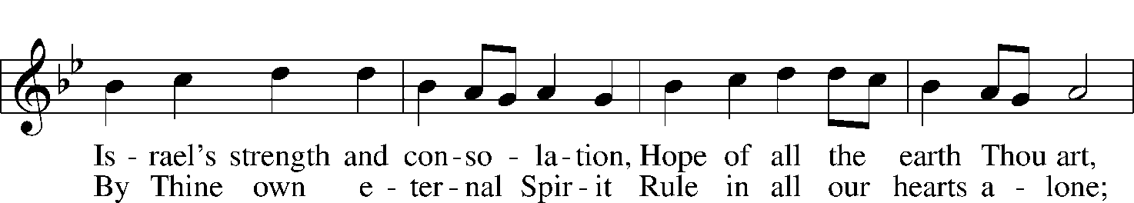
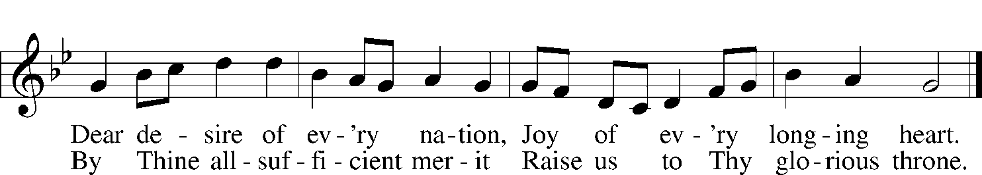
Public domain

